7.1 - Institutional Values and Social Responsibilities

Specific facilities provided for women in terms of: a. Safety and security b. Counseling c. Common Rooms **Safety and Security**

**Main gate of college with Security guard**

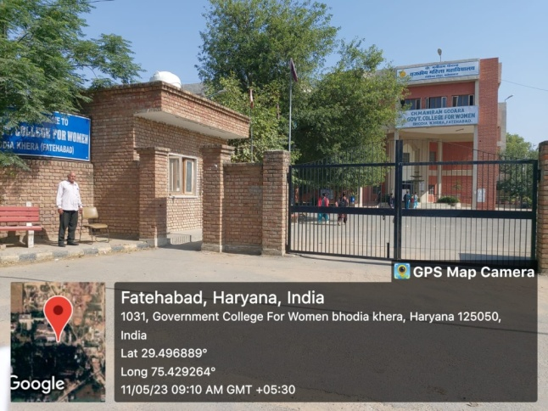

**Fencing on College wall**

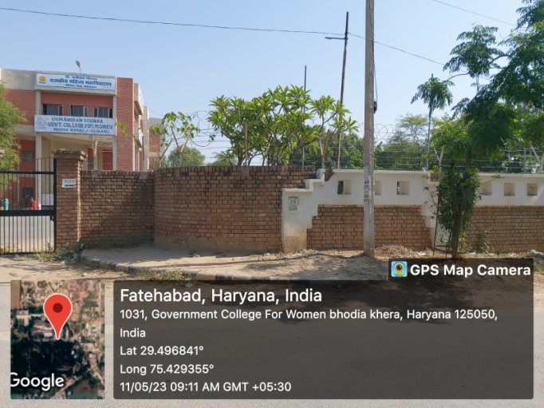

**Girl’s Hostel Main gate**

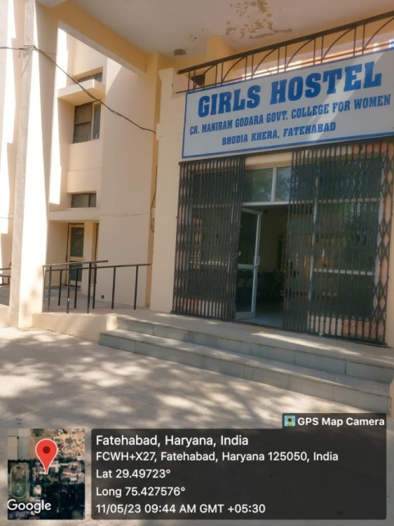

**Fencing on Girl’s Hostel Wall**

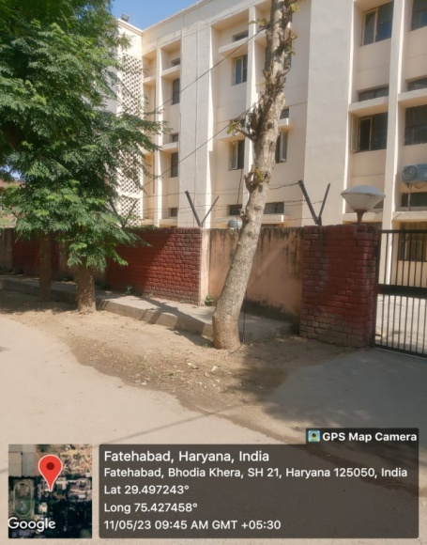

**COMMON ROOM**

