**Facilities in the Institution for the management of the following types of degradable and non-degradable waste**

**SOLID WASTE MANAGEMENT (GARBAGE HOUSE)**

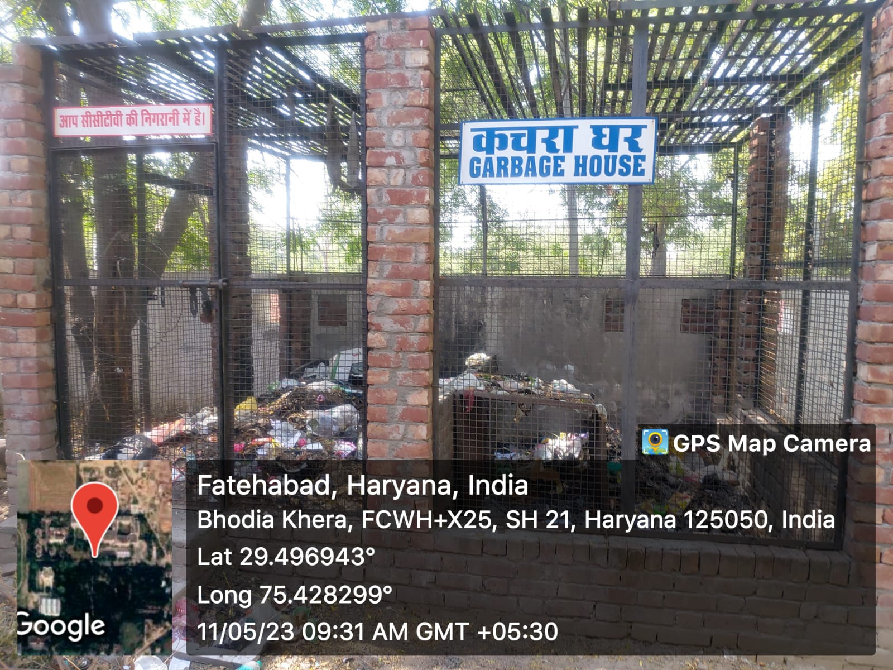

**LIQUID WASTE MANEGEMENT (SEWAGE DUMPING WELL)**

