Science Exhibition Committee Activities

- Organised a district level science exhibition on 24/10/2017

- College level Science exhibition was held on 31/01/2019

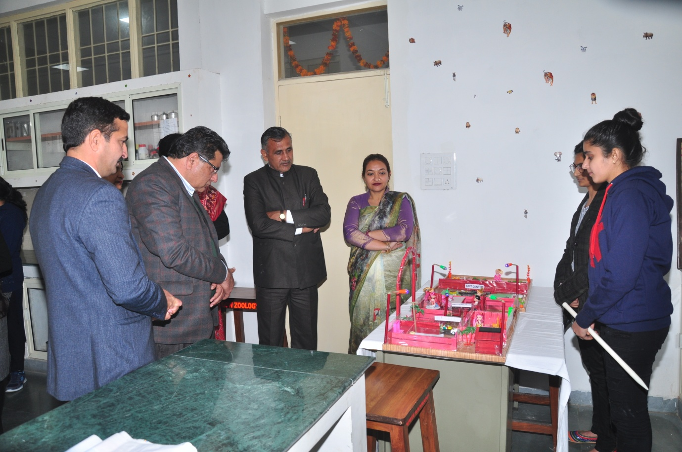
- Inter college science exhibition was held on 14-15/ 02/2019
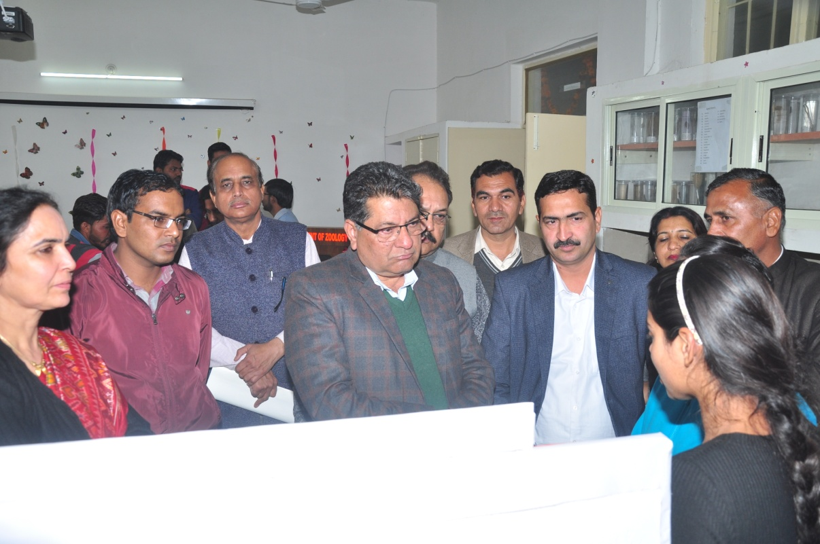
- College level science exhibition was held 08/11/2019
- College level science exhibition was held on 15/01/2021.
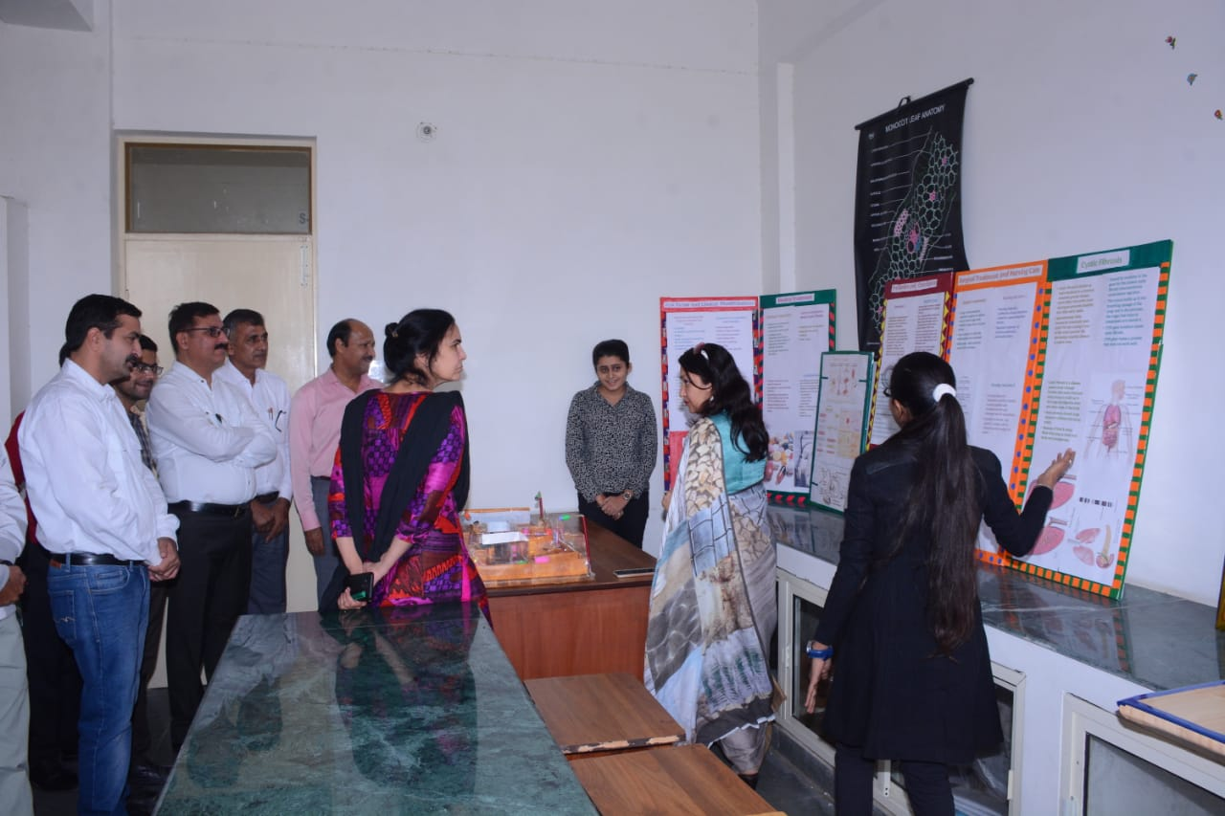
- College level science exhibition was held on 11/11/2021
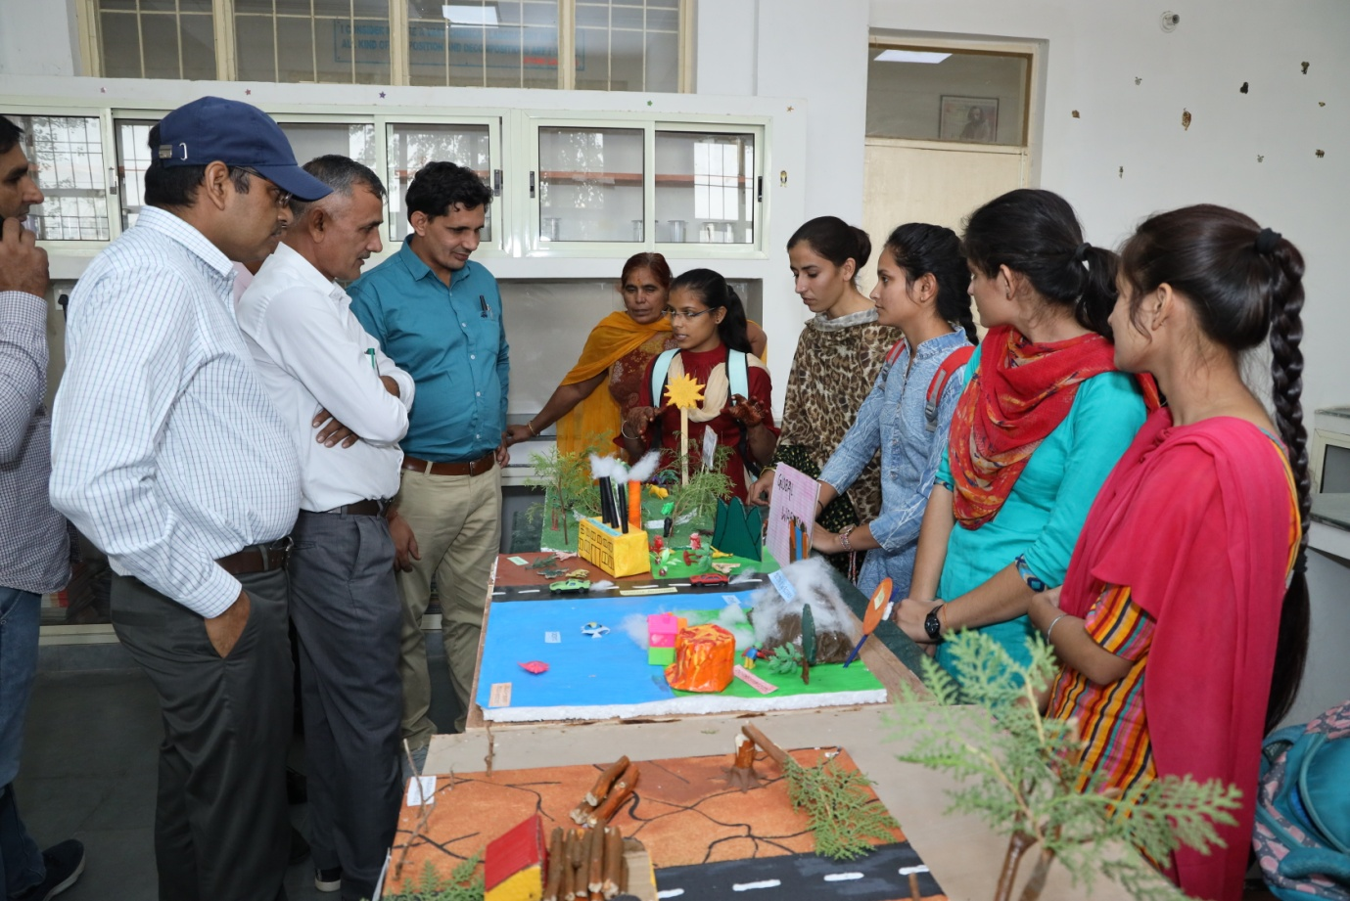

- Inter District level science exhibition was held 23/11/2021
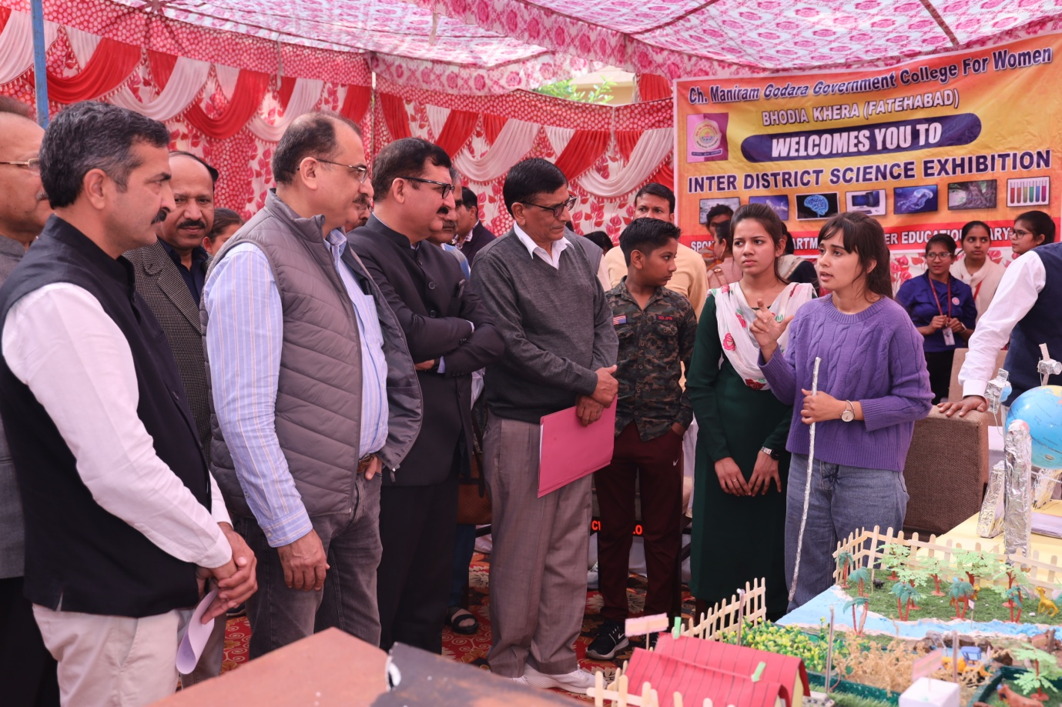

Convenor

Science Exhibition Committee

