Activity 1
One Day National Seminar was organized by Commerce Society in Online Mode on topic “CAREER OPPORTUNITIES IN INDIAN FINANCIAL MARKET” under convener-ship of Dr Mohina. This seminar was approved by SEBI (securities exchange Board of India) Smt. Shakuntala Pareek, Financial Education Trainer, NISM, Resource Person, Bombay Stock Exchange served as key note speaker in the event held on 9th November 2021 for the students of Department of Commerce, CMG GCW Bhodia Khera. Dr Rajesh Mehta, Principal of the college was chief Patron for the event. The students were enlightened with the vast knowledge about the topic by all dignitaries.
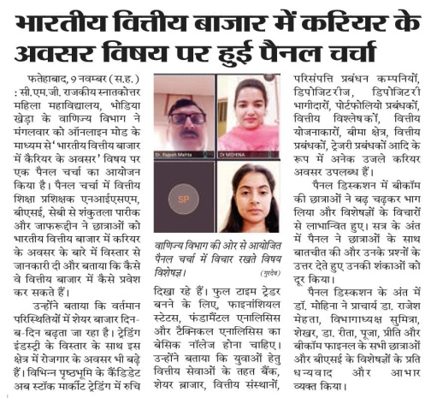
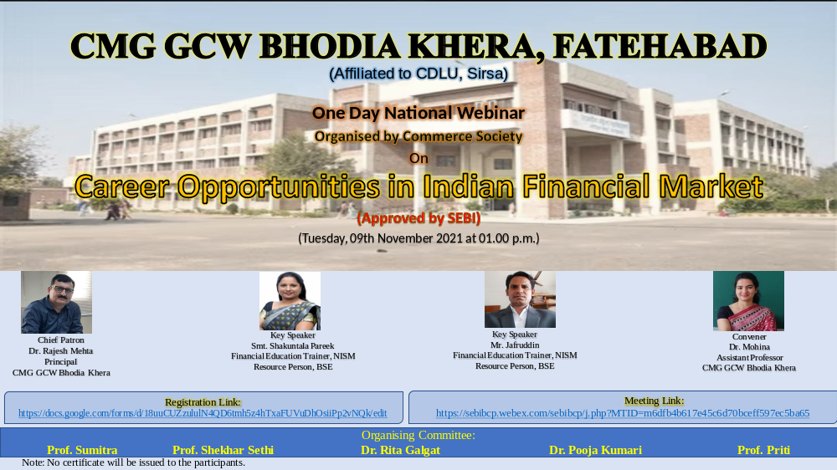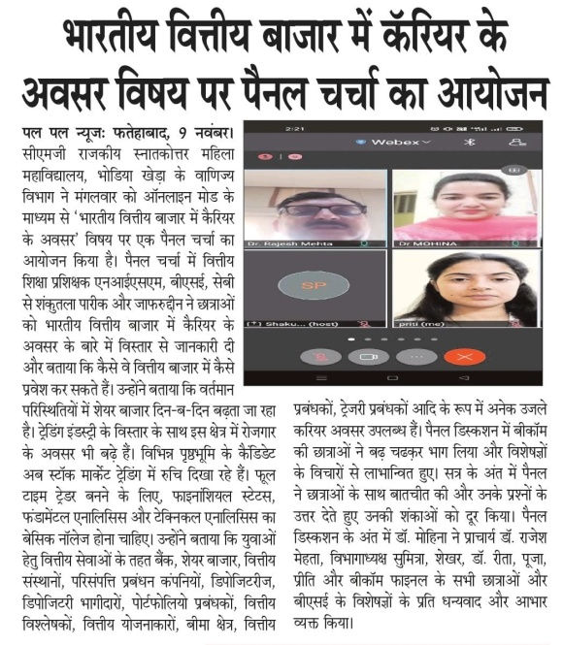

Activity-2
POSTER MAKING AND SLOGAN WRITING COMPETITION was organized Dr Rita Galgat under the aegis of Commerce Society on November 25 ,2021 at 12:30 a.m. DR HAWA SINGH was chief PATRON of the event who encouraged the efforts of students and organizing committee.
Organizer Dr Rita
Patron Dr Hawa Singh
Judges Prof. Sumitra
Dr Mohina
Dr. Pooja Kumari
Slogan Writing Competition Result b
- Anu Devi B.Com III 2941620053
- Ramanpreet Kaur B.Com II 120026003001
- Yukta B.Com III 2941620031
Poster Making Competition Result
i Harjot B.Com III 2941620026
ii Aarti B.Com I 1210261003012
Ritika B.Com II 120026003013
iii Ramlala B.Com III 29416220048
Nisha Rani B.Com I 1210261003010
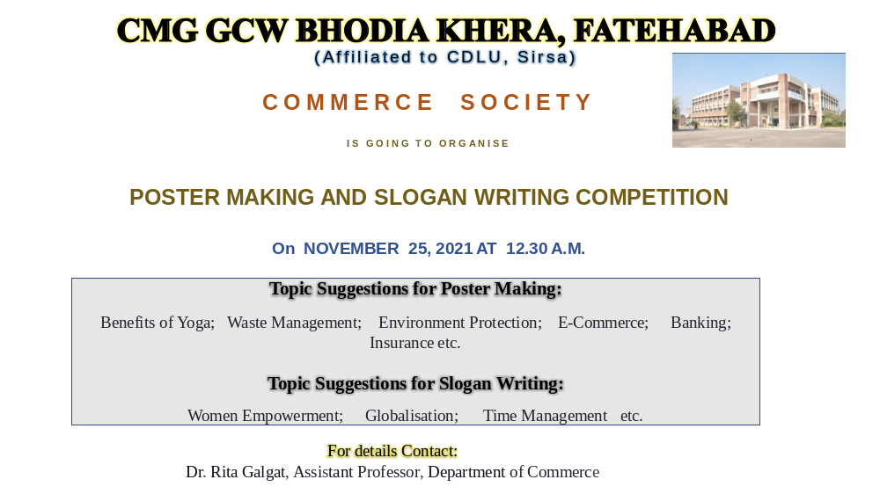

Activity 3
POWERPOINT PRESENTATION COMPETITION was organised by DR POOJA KUMARI under aegis of Commerce Society on November 26, 2021 at 11:00 a.m. in Conference Room.
Organizer Dr Puja Kumari
Patron Dr Hawa Singh
Judges Prof. Sumitra Rani
Prof. Shekhar Sethi
Dr Mohina
Prof. Preeti
Result
1 Renuka BCom 3rd 29416 20017
2 Neha BCom 3rd 29416 20051
3 Priyanka Bishnoi BCom 3rd 29416 20052

Organising Committee—Prof. Sumitra, Prof. Shekhar, Dr Mohina, Dr Rita, Prof.Priti

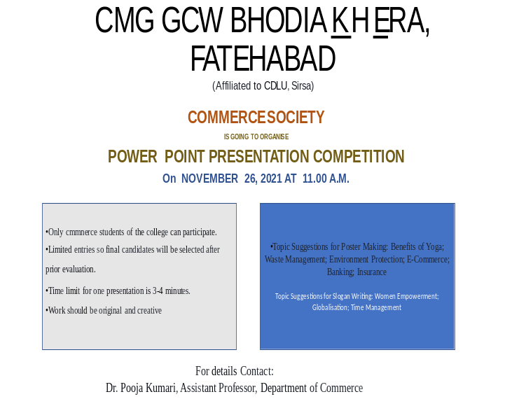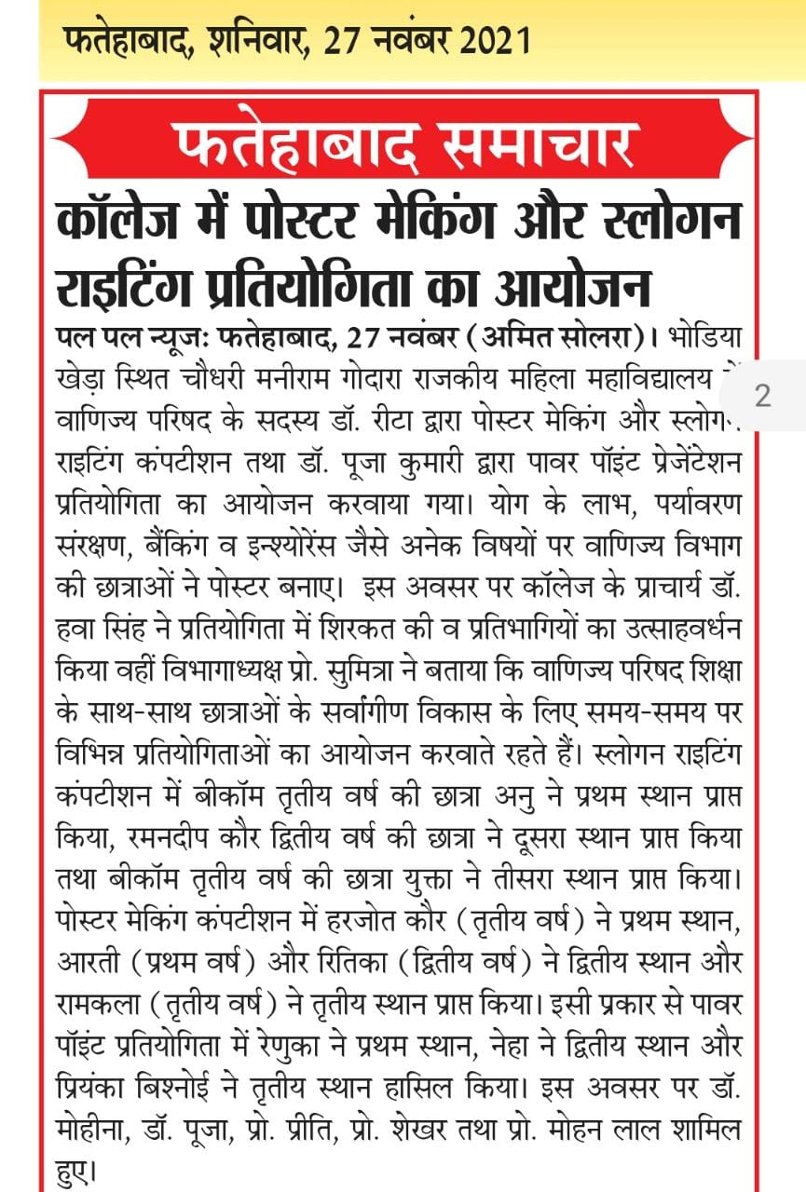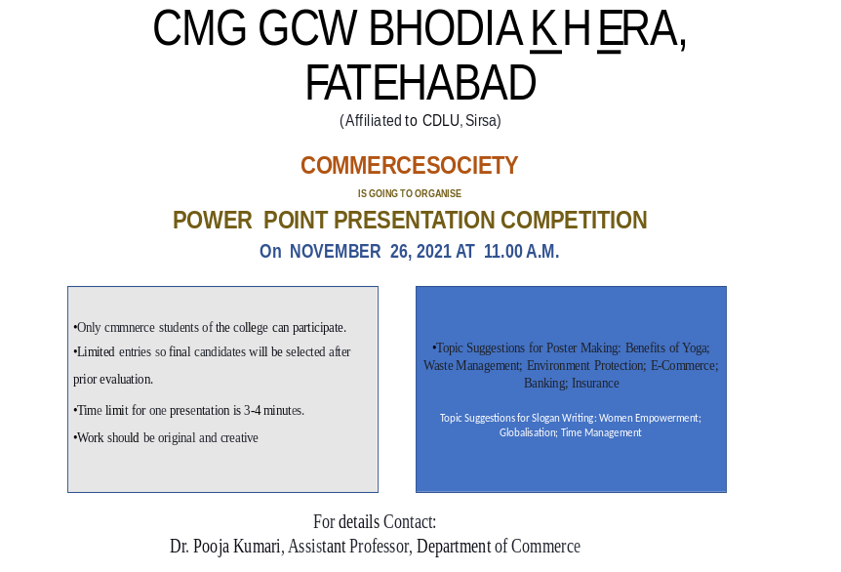

Activity 4
PANEL DISCUSSION was conducted under the convenorship of Professor Sumitra on the topic, ”CAREER OPPORTUNITIES AFTER GRADUATION IN COMMERCE” on Tuesday 4January, 2022 at 11:30 a.m. where in Dr DIMPLE,Asst.Prof.,Aggarwal College, Faridabad served as key speaker through online mode. The objective of the activity was to provide career counselling to the students of B.Com Dr Hawa Sing, Principal, CMG GCW BhodiaKhera served as patron of the activity. Dr Mohina provided vote of thanks to organising committe, speaker and petron for making the activity a success.

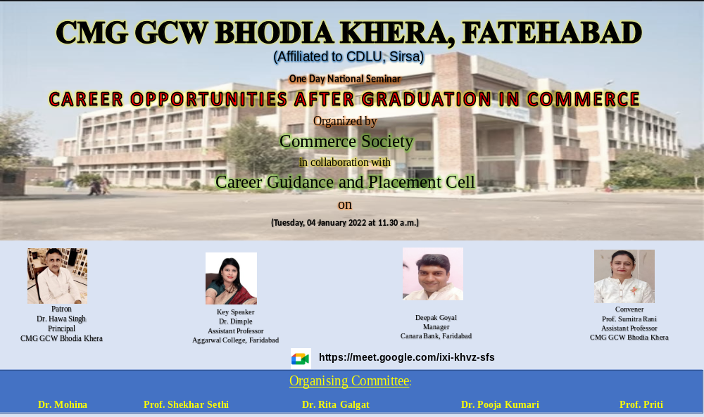
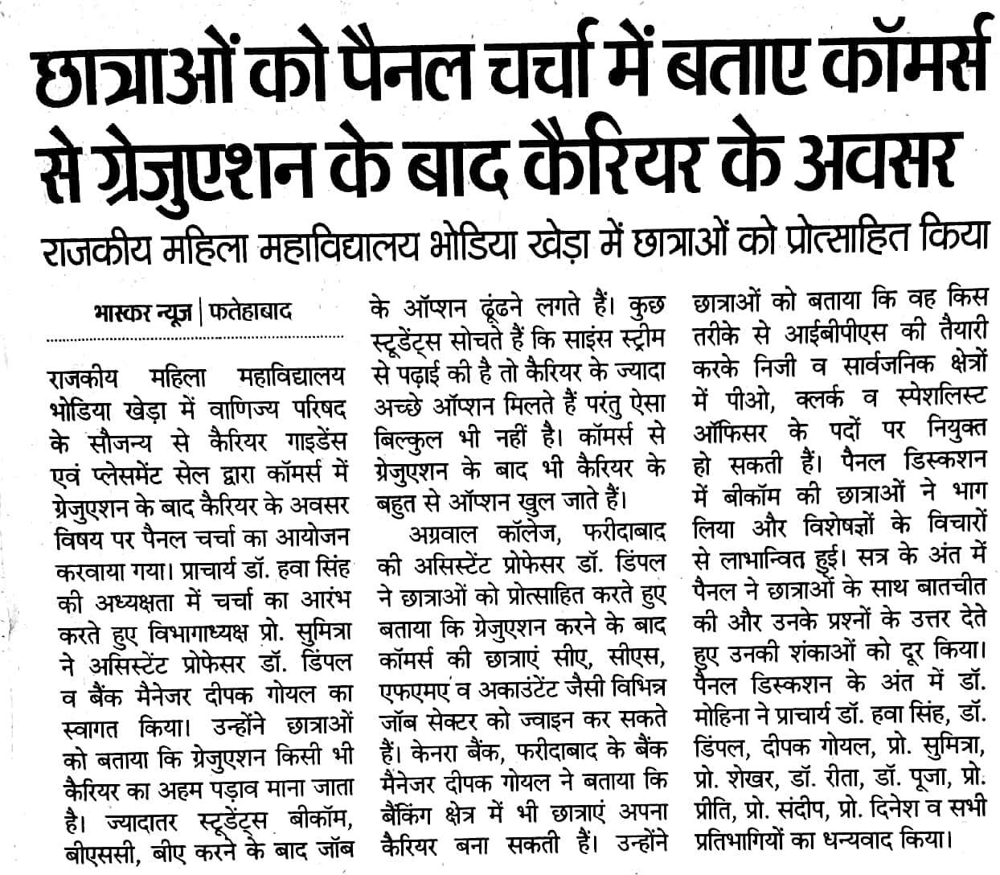

Activity-5
PANEL DISCUSSION was conducted through online mode on topic,”Career Opportunities (After Graduation) in Banking “ where Mr Deepak Goyal Manager, Canara Bank, Faridabad served as key speaker on 4 January 2022 at 12:30 p.m. through Google meet. Professor Sumitra, convener of the activity addressed the students to enlighten them to seek maximum first-hand information about entry in banking sector .The Patron of the activity Dr Hawa Singh motivated the students towards financial literacy. Dr Mohina provided vote of thanks to all.



